|  |  |  |  |  |  |  |  |  |  |
| --- | --- | --- | --- | --- | --- | --- | --- | --- | --- |
| **SCHOOL OF COMPUTER SCIENCE AND ARTIFICIAL INTELLIGENCE** | | | | | **DEPARTMENT OF COMPUTER SCIENCE ENGINEERING** | | | | |
| **ProgramName:**B. Tech | | | | **Assignment Type: Lab** | | | **AcademicYear:**2025-2026 | | |
| **CourseCoordinatorName** | | | | Venkataramana Veeramsetty | | | | | |
| **Instructor(s)Name** | | | | |  | | --- | | Dr. V. Venkataramana (Co-ordinator) | | Dr. T. Sampath Kumar | | Dr. Pramoda Patro | | Dr. Brij Kishor Tiwari | | Dr.J.Ravichander | | Dr. Mohammand Ali Shaik | | Dr. Anirodh Kumar | | Mr. S.Naresh Kumar | | Dr. RAJESH VELPULA | | Mr. Kundhan Kumar | | Ms. Ch.Rajitha | | Mr. M Prakash | | Mr. B.Raju | | Intern 1 (Dharma teja) | | Intern 2 (Sai Prasad) | | Intern 3 (Sowmya) | | NS_2 ( Mounika) | | | | | | |
| **CourseCode** | | | 24CS002PC215 | **CourseTitle** | | AI Assisted Coding | | | |
| **Year/Sem** | | | II/I | **Regulation** | | R24 | | | |
| **Date and Day**  **of Assignment** | | | Week1 - Tuesday | **Time(s)** | |  | | | |
| **Duration** | | | 2 Hours | **Applicableto**  **Batches** | | 24CSBTB01 To 24CSBTB39 | | | |
| **AssignmentNumber:1.2**(Present assignment number)/**24**(Total number of assignments) | | | | | | | | | |
|  | | | | | | | | | |
|  | **Q.No.** | **Question** | | | | | | ***ExpectedTime***  ***to complete*** |  |
|  | 1 | Lab 1: Environment Setup – GitHub Copilot and VS Code Integration  **Lab Objectives:**   * To install and configure GitHub Copilot in Visual Studio Code. * To explore AI-assisted code generation using GitHub Copilot. * To analyze the accuracy and effectiveness of Copilot's code suggestions. * To understand prompt-based programming using comments and code context   **Lab Outcomes (LOs):**  After completing this lab, students will be able to:   * Set up GitHub Copilot in VS Code successfully. * Use inline comments and context to generate code with Copilot. * Evaluate AI-generated code for correctness and readability. * Compare code suggestions based on different prompts and programming styles.   **Task Description#1**   * Write a comment: # Function to check if a string is a valid palindrome (ignoring spaces and case) and allow Copilot to complete it.   **Expected Output#1**   * A function that correctly returns True for phrases like "A man a plan a canal Panama"   **Task Description#2**   * Generate a Python function that returns the Fibonacci sequence up to n terms. Prompt with only a function header and docstring   **Expected Output#2**   * AI completes the function logic using loop or recursion with accurate output   **Task Description#3**   * Write a comment like # Function to reverse a string and use Copilot to generate the function.   **Expected Output#3**   * Auto-completed reverse function   **Task Description#4**   * Generate a program that simulates a basic calculator (add, subtract, multiply, divide). Write the comment: # Simple calculator with 4 operations and let AI complete it.   **Expected Output#4**   * Fully working calculator with input/output and operator selection logic   **Task Description#5**   * Use a comment to instruct AI to write a function that reads a file and returns the number of lines..   **Expected Output#5**   * Functional implementation using open() or with open() and readlines()   **Note: Report should be submitted a word document for all tasks in a single document with prompts, comments & code explanation, and output and if required, screenshots**  **Evaluation Criteria:**   | **Criteria** | **Max Marks** | | --- | --- | | Task #1 | 0.5 | | Task #2 | 0.5 | | Task #3 | 0.5 | | Task #4 | 0.5 | | Task #5 | 0.5 | | **Total** | **2.5 Marks** | | | | | | | Week1 - wednesday |  |

**Task Description#1**

* Write a comment: # Function to check if a string is a valid palindrome
* (ignoring spaces and case) and allow Copilot to complete it.

OUTPUT:

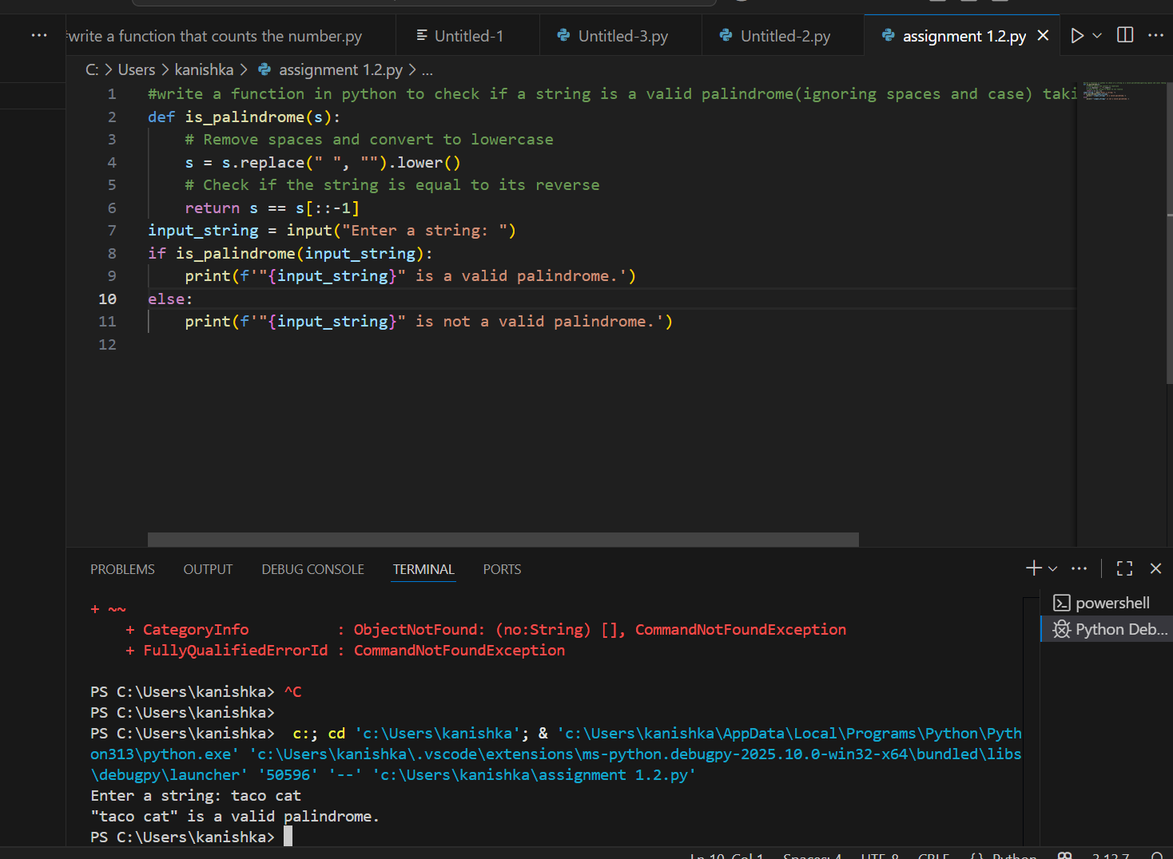

**Task Description#2**

* Generate a Python function that returns the Fibonacci sequence up to n terms. Prompt with only a function header and docstring

OUTPUT:

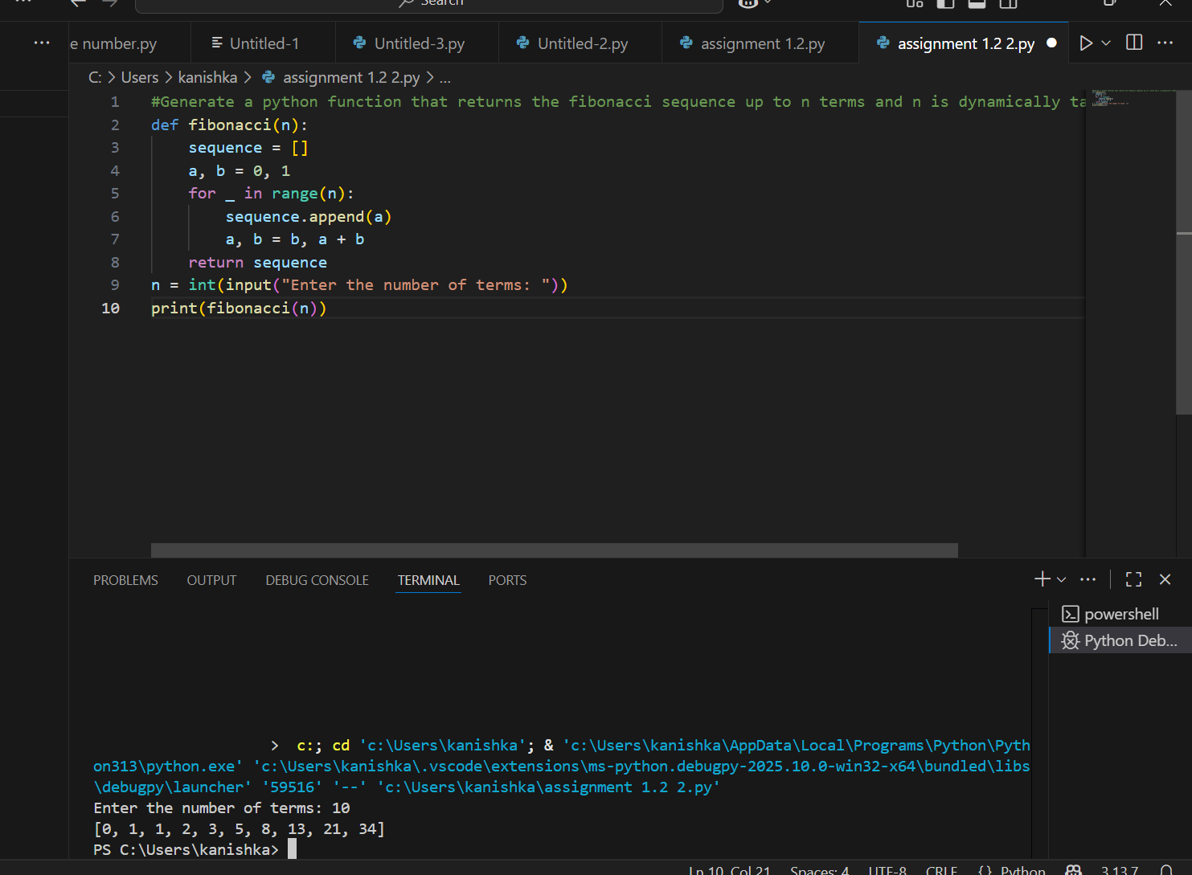

**Task Description#3**

* Write a comment like # Function to reverse a string and use Copilot to generate the function.

OUTPUT:

**Task Description#4**

Generate a program that simulates a basic calculator (add, subtract, multiply, divide). Write the comment: # Simple calculator with 4 operations and let AI complete it.

OUTPUT:

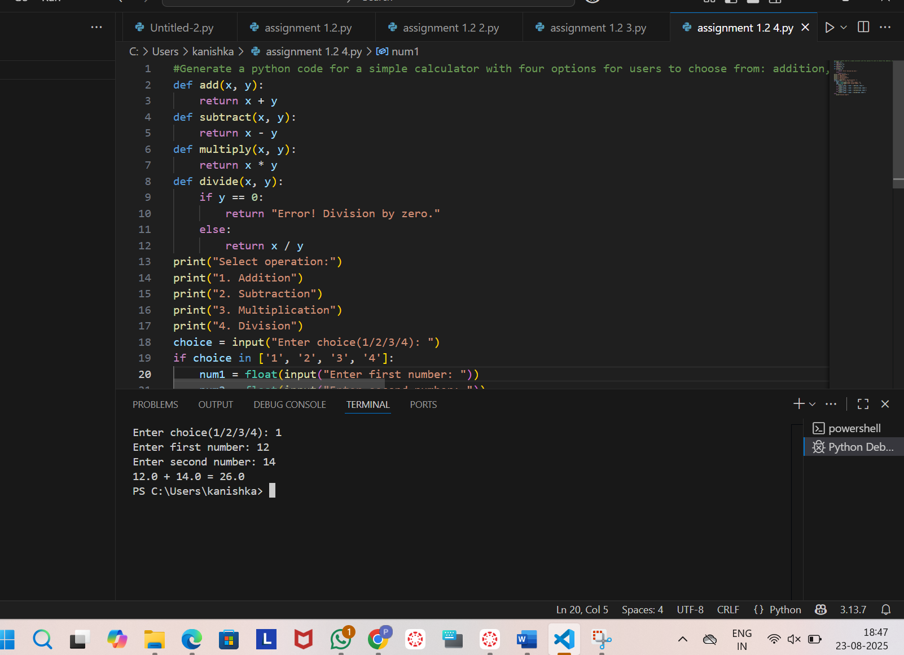

**Task Description#5**

* Use a comment to instruct AI to write a function that reads a file and returns the number of lines..

OUTPUT:

